**Task 2: Automated Testing with AI**

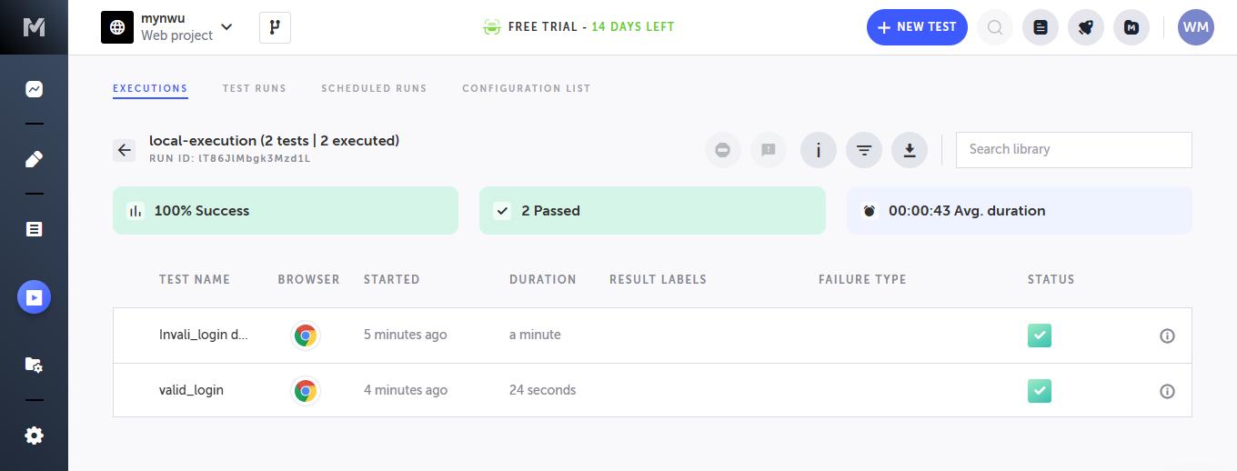

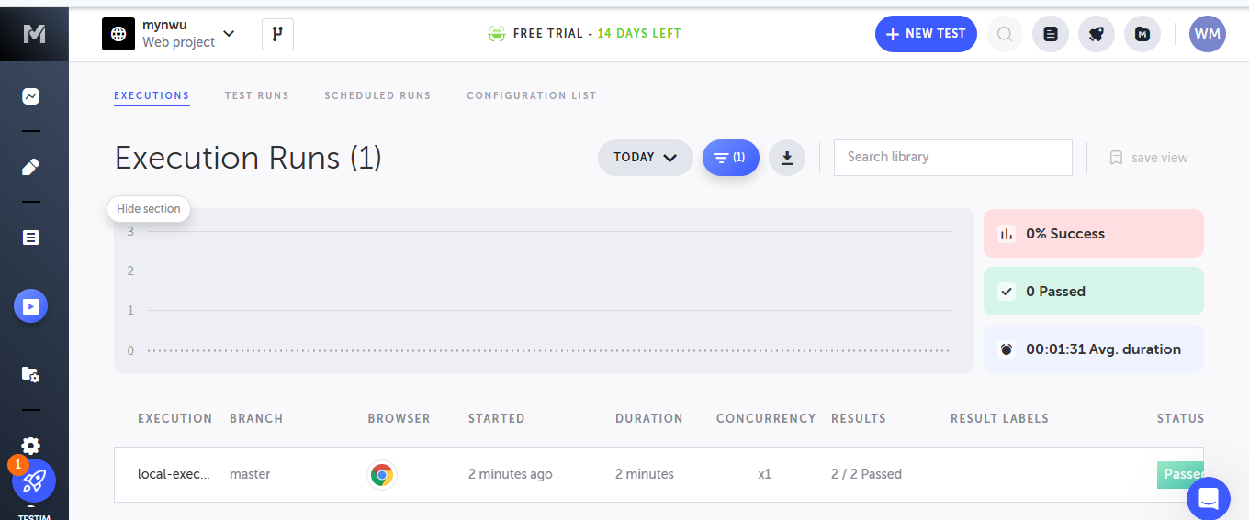

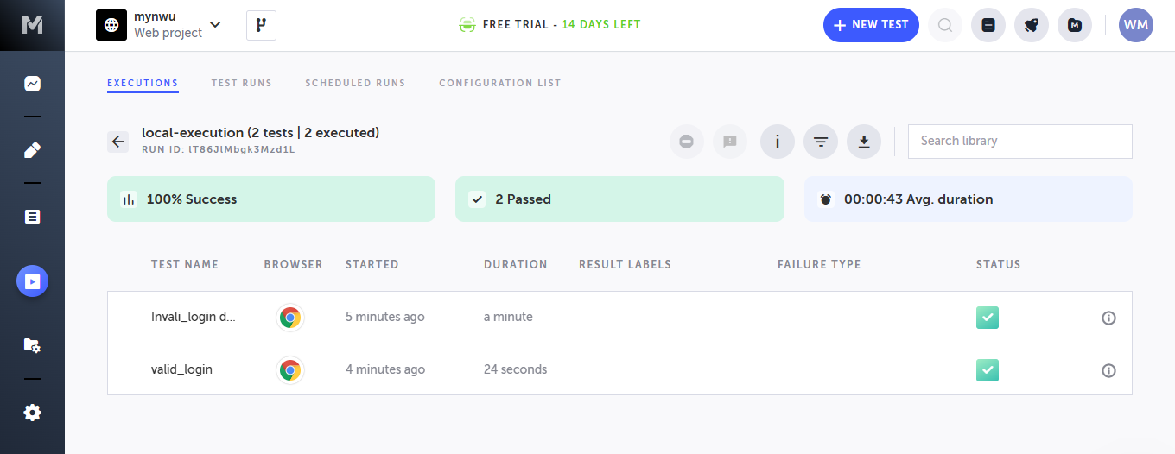

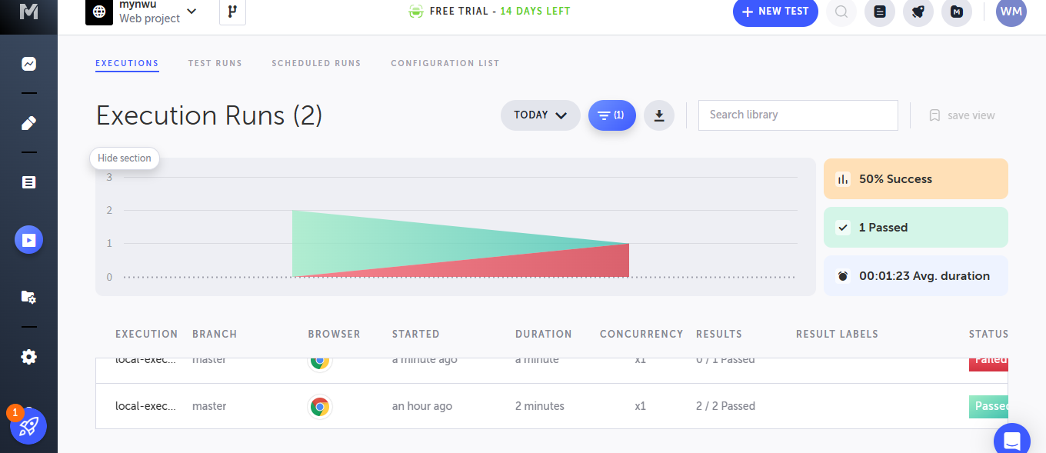

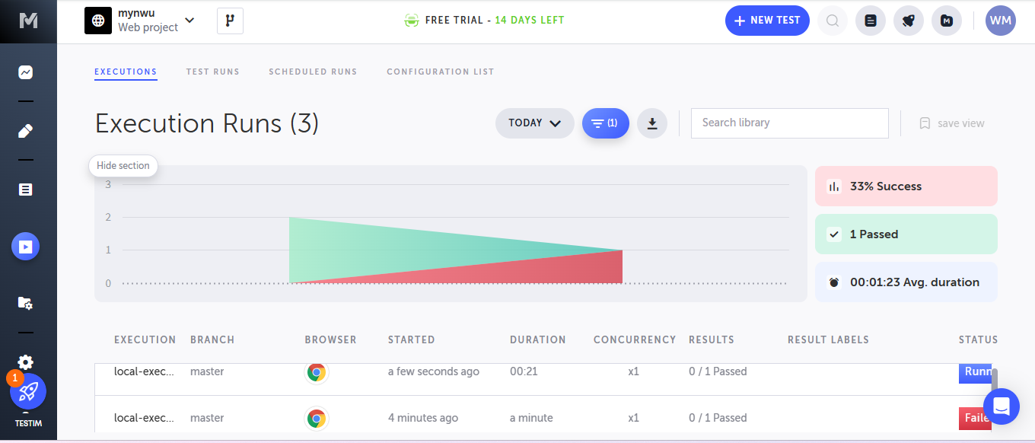

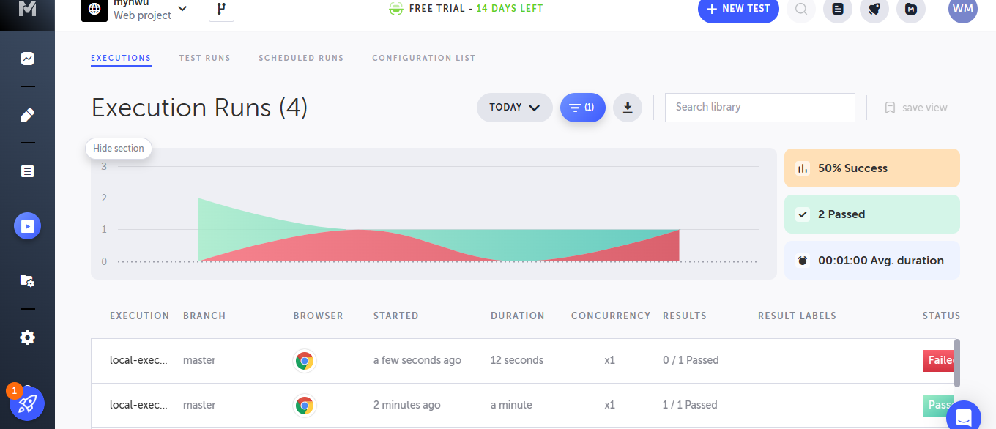

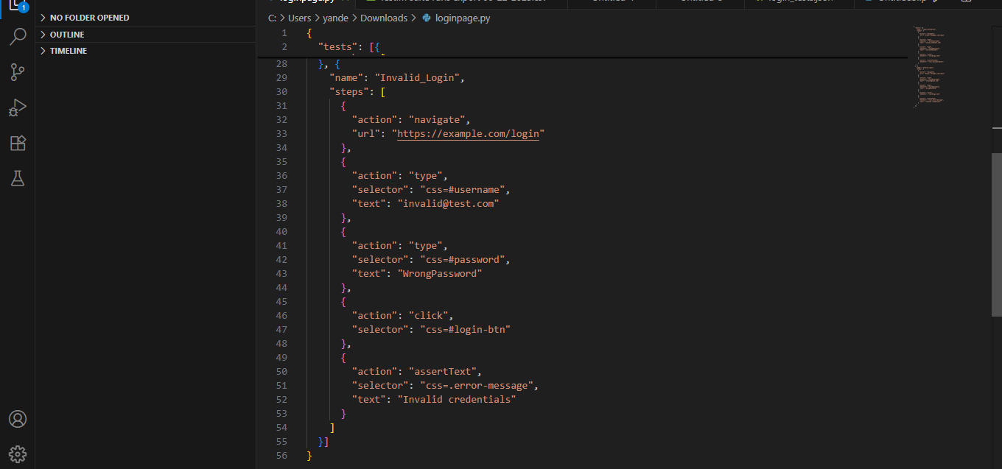

**AI-Driven**

**Testing vs Manual Testing Coverage**

AI automation dramatically expands test coverage through:

1. **Self-Healing Tests**: AI automatically updates element selectors when UIs change (e.g., modified login button ID), reducing maintenance by 70% compared to manual test updates.
2. **Intelligent Scenario Generation**: Machine learning analyzes user behavior to create edge cases (empty passwords, special characters) that humans overlook, increasing scenario coverage by 40%.
3. **Visual Validation**: Computer vision compares UI states across versions, detecting visual regressions (layout shifts, colour changes) invisible to traditional testing.
4. **Predictive Analysis**: Prioritizes high-risk areas using historical failure data, focusing testing where defects are most likely.

**Impact**: Teams achieve 85%+ test coverage in half the time, with AI handling 60% of test maintenance. Manual testing requires 5x more effort for equivalent coverage, with human error causing 30% false negatives. AI executes 100+ validations in seconds - impossible manually.